IT’S YOUR-DAY sale
  - Save & Slay the SEBATU Way
Sebatu Body Wave  5%  Sebatu Straight  5%  Sebatu Curly  5%  Unique  Satin Bonnets  10% | 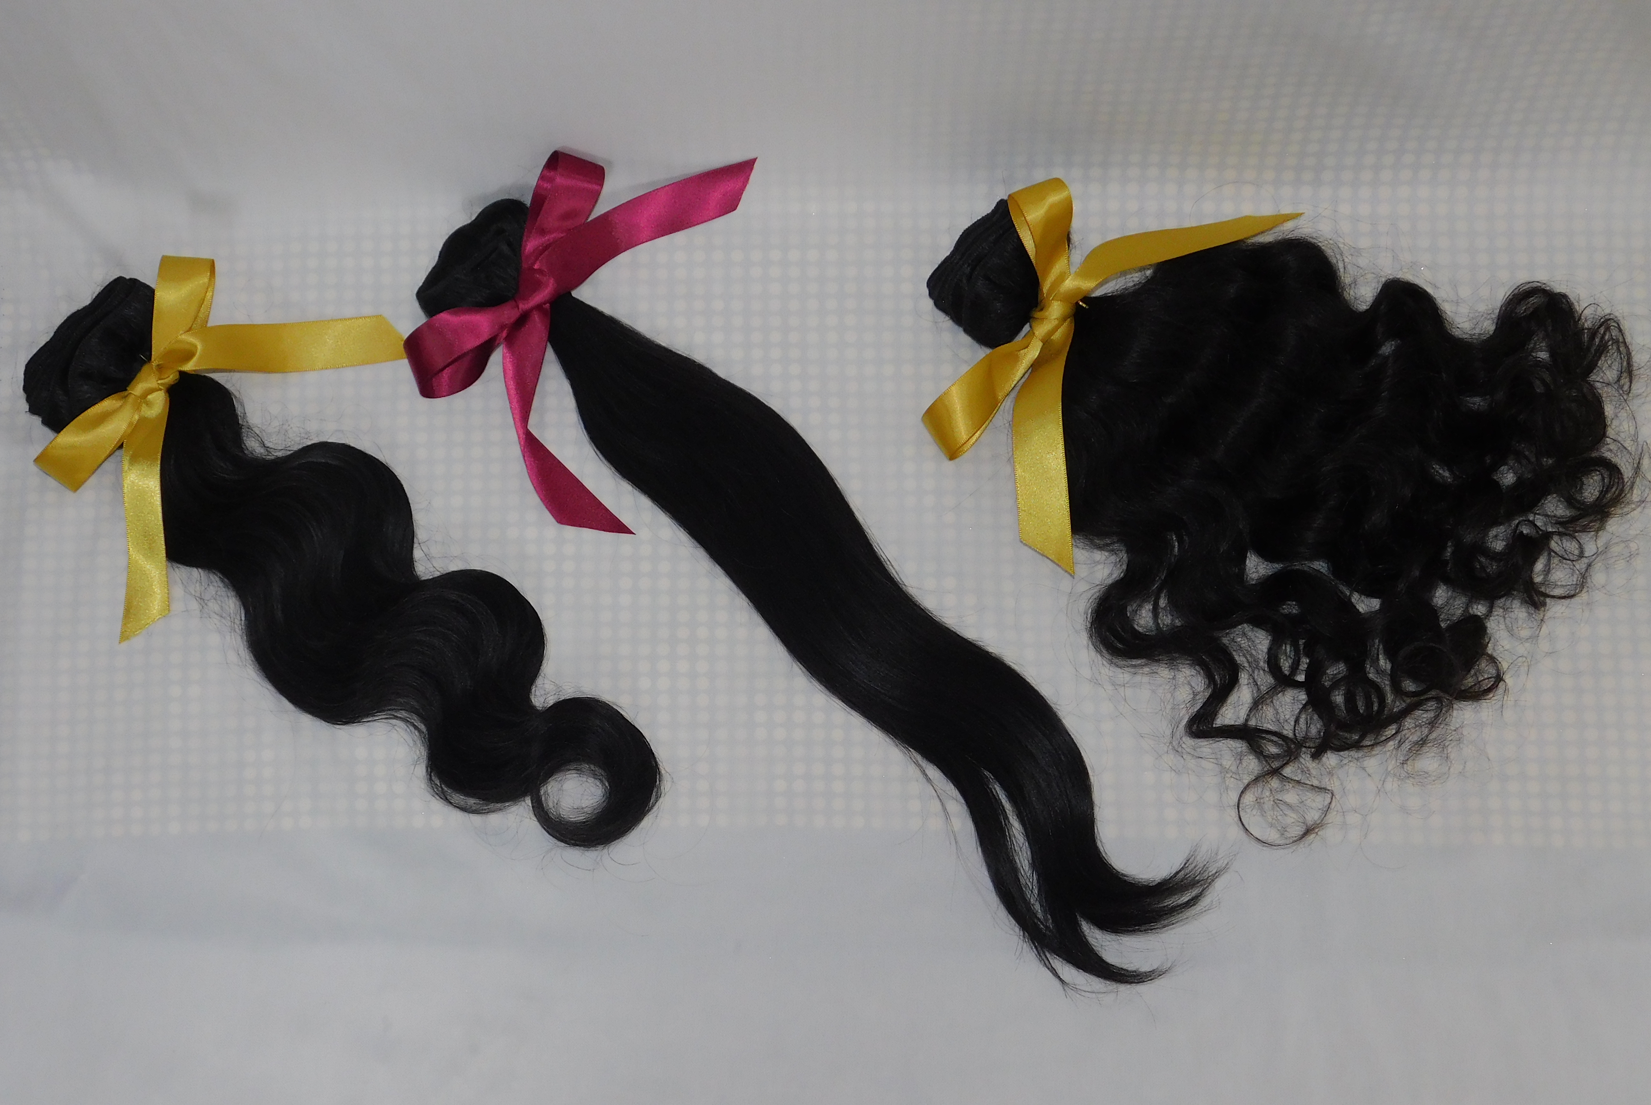
LOCAL DELIVERY AVAILABLE
BRAIDING SERVICES AVAILABLE

SEBATU Luxury Hair Collections

Phone: (469) 475-3365

Online: www.sebatuluxuryhaircollecitons.com

Treat yourself! SEBATU Luxury Hair Collections home of 100% virgin hair extensions. Shop SEBATU be SEBATU

